Team name: Project4

Scrum Master: Jazlyn

Date: 04 April 2019

|  |  |  |  |
| --- | --- | --- | --- |
| **Team Member** | **What did you do since the last scrum?** | **What do you plan to do before the next scrum?** | **What obstacles do you have?** |
| Jeffrey | Make it so user can login and logout | Populate profile page | Sending info to DB |
| Marc | Started Unit Testing | More Unit Testing | Setting up DB for unit testing |
| Jazlyn | Updated Documentation | Make sample games show up with EJS | Homework in other classes |
| Brandon | Working on DB structure | Populating DB | Other class exam study |

Burndown:

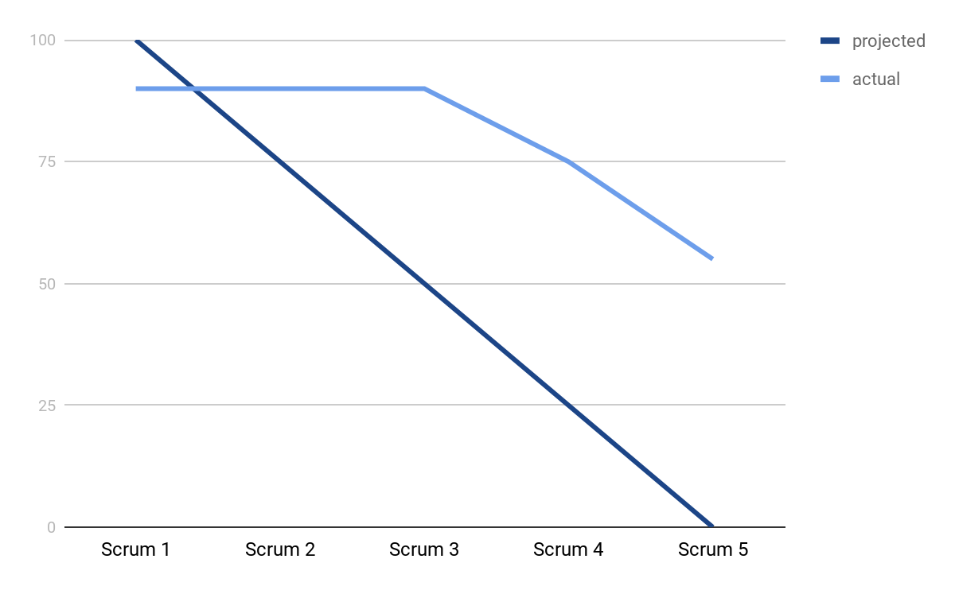

Screenshot of your task board:

